[Video 2:](https://www.youtube.com/watch?v=LpneRZljv9Y)

Install

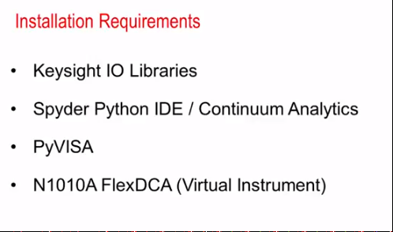

[Video 3:](https://www.youtube.com/watch?v=1hChvaebqyo)

[Video 9:](https://www.youtube.com/watch?v=a4auNa6JTvs) Read write file

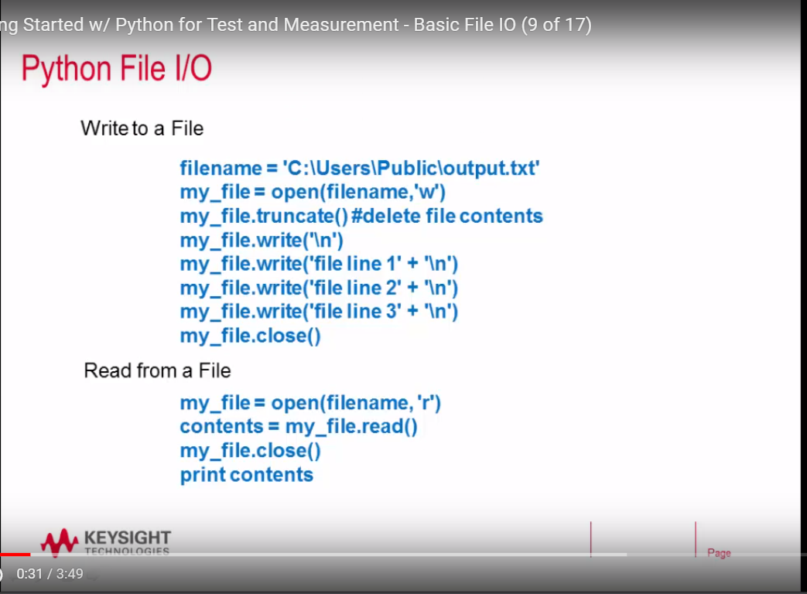

[Video 10:](https://www.youtube.com/watch?v=v9ZTh_VMTEU) Exception Handle

[Video 11:](https://www.youtube.com/watch?v=6IGGc6ZOKSs) Array generation and plotting

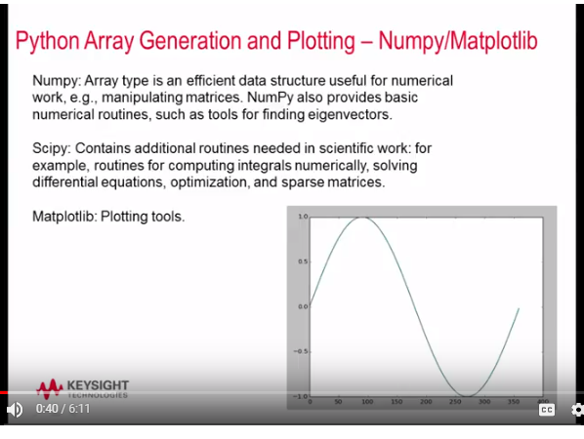 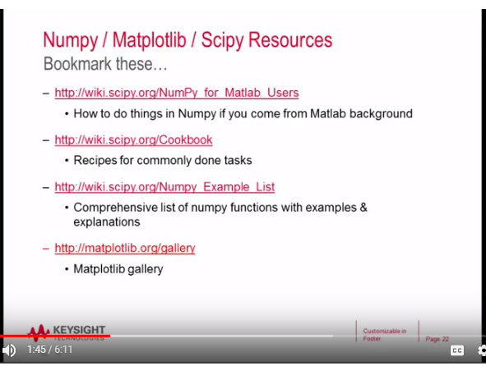

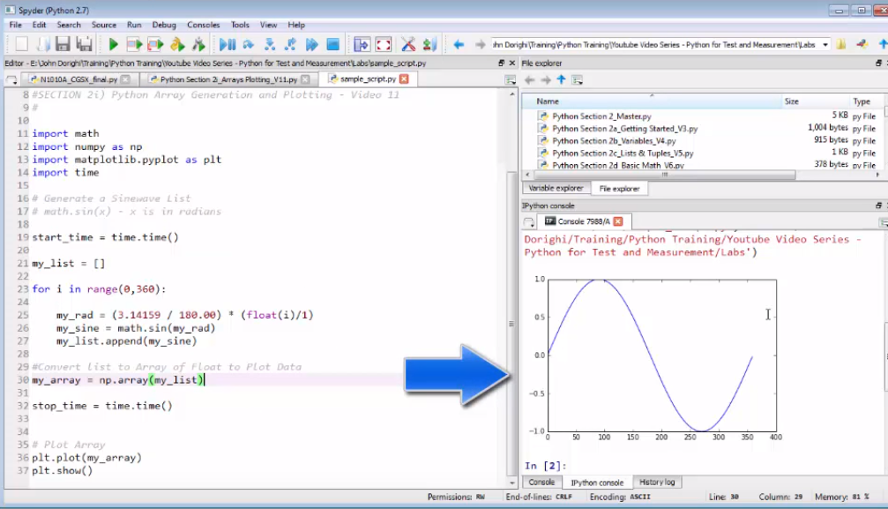

[Video 12:](https://www.youtube.com/watch?v=Fd7AtWUwlI4) connect to keysight instruments

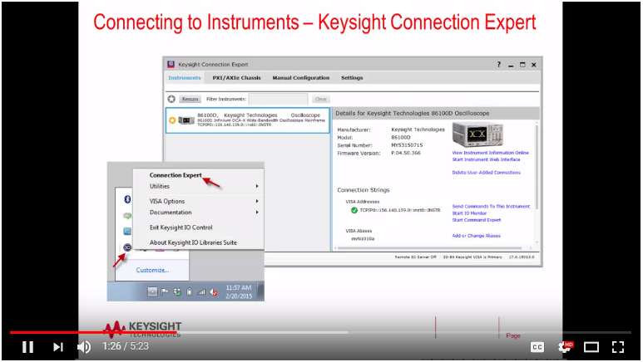

[Video 15:](https://www.youtube.com/watch?v=iHGJ7W4Gay4)